Multiple-choice section – choose the correct answer

Question 1 [3.1]

The coefficient of *x* in 3*x*2 – 5*x* + 2*xy* – 9 is:

A 3 B -5 C 2 D -9

Question 2 [3.2]

If *q* = , what is the value of *q* where *p* = -3?

A -1 B -11 C 1 D 11

Question 3 [3.2]

If *a* = -3 and *b* = 2, then 3*a*2 – 4*b*3 is equal to:

A -42 B -6 C -5 D 59

Question 4 [3.3]

The formula *s = ut +* is used to find the speed of an object. If *u =* -40, *a* = 10 and *t* = 6 are substituted into the formula, *s* is equal to:

A -60 B 60 C 420 D 3360

Question 5 [3.4]

Subtract *x* – 3*y* + 5*z* from 2*x* + 5*y* – 7*z*.

A *x* + 2*y* – 2*z* B *x* + 8*y* – 12*z* C 3*x* + 2*y* + 4*z* D -*x* – 8*y* + 12*z*

Question 6 [3.5]

Simplify -4*a* × 3*b* × -2*c*.

A -24*abc* B -3*abc* C 9*abc* D 24*abc*

Question 7 [3.5]

Simplify 64*e* ÷ -56*ef* × 7*f*.

A -8 B -8*f* 2 C - D -

Question 8 [3.6]

Expand the expression -3*mn*(*m*2 – 4*n*).

A -3*m*3 – 4*n*2 B -3*m*3 + 4*n*2 C -3*m*3*n* – 12*mn*2 D -3*m*3*n* + 12*mn*2

Question 9 [3.6]

When the expression is expanded and simplified, it is equal to:

A  B  C  D 

Question 10 [3.7]

Factorise 2*ab*2 – 8*abc*.

A 2(*ab*2 – 4*abc*) B 2*a*(*b*2 – 4*c*) C 2*ab*(*b* – 4*c*) D -2*ab*(*b* + 4*c*)

Multiple-choice results: ___ / 10

Short answer section

Question 11 3 marks

Choose the correct word from the following list to fill the gaps in the following sentences.

*like terms coefficient factorising expanding constant formulas*

(a) Writing an expression with a common factor and brackets is called ____________________  
an expression.

(b) Using the distributive law to write an expression without brackets is called __________________ an expression.

(c) When 3*a* – 4*b* + 5*a* + 6*b* is simplified to 8*a* + 2*b*, you have collected ____________________.

Question 12 3 marks [3.2]

Toni answered the question below in a maths test, but she made a mistake.  
Circle the error and write the correct solution.

Substitute *a* = -3 and *b* = 5 into the following expression: 4*ab* – 5*b.*

Toni’s working

4*ab* – 5*b*

= 4 × -3 × 5 – 5 × 5

= 60 – 25

= 35

Question 13 5 marks [3.2]

Given that *p* = 1, *q =* -3 and *r* = 5, evaluate:

(a) 2*pq* (b) *q*(*p* + *r*)

(c) (2*p* – *q*)(*q* – 2*r*)

Question 14 3 marks [3.3]

The kinetic energy, *E*, of an object can be calculated from the formula *E* = *mv*2, where *m* is the mass of the object and *v* is its speed.

(a) Find the kinetic energy of an object that has a mass of 50 kg and is moving at a speed of 15 m/s.

(b) An object moving at 5 m/s has a kinetic energy of 1250 J. What is its mass?

Question 15 3 marks [3.4]

Simplify these expressions, where possible.

(a) 8*r* – 2*r* – 9 (b) 7*d* – 3*h* + 4*d* + 4*h* (c) 7*x* + 2 – (5 – 6*x*)

Question 16 5 marks [3.5]

Simplify each of these expressions.

(a) -5*a* × 3*b* × 6*a* (b) × 2*hk*

(c) 63*x*2*y*2 ÷ 9*xy* + (-4*y*) × 5*x*

Question 17 5 marks [3.6]

Expand and simplify each of the following expressions.

(a) -3(6*r* – 4) (b) 3*x*(*y* – 5) – 4*xy*

(c) 2*m*2(4*n* – 5) – 10*m*(*m* + 2*n*)

Question 18 3 marks [3.4, 3.5]

**(a)** Write an expression for the perimeter of the shape below, and simplify it.

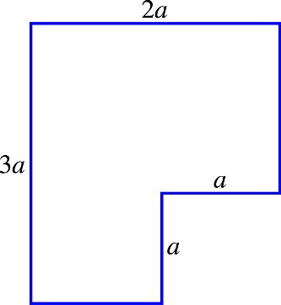

**(b)** Write an expression for the area of the shape above, and simplify it.

Question 19 5 marks [3.7]

Factorise the following expressions.

(a) 3*xy* – 6*y2* (b) 42*b3c*– 18*bc* (c) 8*cd*2 + 10*c2d –* 32*c*3*d*2

Short answer results: ___ / 35

Extended answer section

Question 20 9 marks [3.2, 3.4, 3.6, 3.7]

(a) Flocks of birds often fly in V patterns, as shown in these diagrams.

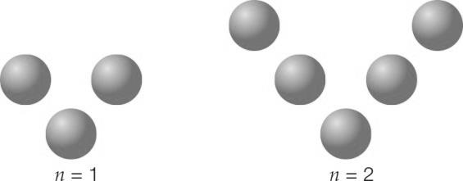

The number of pairs of birds behind the leading bird (the single bird at the vertex of the V) is represented by the letter *n*. The total number of birds in the V pattern is represented by the letter *B*. The formula relating *n* and *B* is *B* = 2*n* + 1.

**(i)** In the table, complete the column labelled *B*.

|  |  |  |
| --- | --- | --- |
| *n* | *B* | *J* |
| 1 | 3 | 5 |
| 2 | 5 |  |
| 3 |  | 13 |
| 5 |  |  |

**(ii)** If 139 birds are seen flying in a large V pattern, what is the value of *n*?

**(b)** Groups of fighter jets often fly in W patterns, represented by the formula *J* = 4*n* + 1,  
where *n* = number of pairs behind each leading jet and *J* = total number of jets.   
Complete the column labelled *J*in the table above.

(c) One day, some flocks of birds flying in V patterns are seen together with some jets flying in W patterns.

(i) Write an expression for the total number of birds and jets in terms of *n*.

(ii) Factorise the expression in (c)(i).

(d) The expression (*a* + *b*)(*c* + *d*) can be expanded by rearranging it to *a*(*c* + *d*) + *b*(*c* + *d*). Use the same method to obtain an expression for *B* × *J*.

Question 21 3 marks [3.1]

Nywajara is one third the age of her brother, Jarunji. In five years’ time, she will be half her brother’s age. If Nywajara is *n* years old:

(a) write an expression in terms of *n* to show how old Jarunji is now

(b) write two different expressions in terms of *n* to show how old Jarunji will be in five years’ time.

Question 22 10 marks [3.1, 3.4, 3.6]

A rectangle has dimensions such that the length is 8 cm longer than the width.This is represented by the diagram below.

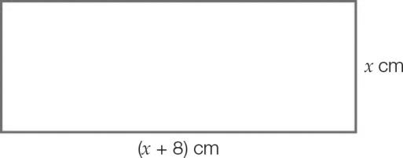

(a) Write an expression for the area of the rectangle. Expand and simplify your expression.

(b) The length is increased by 50% and the width is increased by 20%.

**(i)** Write an expression for the new length and an expression for the new width of the rectangle.

**(ii)** What is the area of this new rectangle? Expand and simplify your expression.

**(iii)** What is the increase in the area of the new rectangle (in terms of *x*)? Comment on this increase.

(c) After these increases, the perimeter of the new rectangle is 78 cm.

**(i)** Suggest a value for *x*.

**(ii)** Use this value to calculate the perimeter of the original rectangle.

Extended answer results: ___ / 22

TOTAL test results: ___ / 67